Training Fiche

Title | Resources for Vocational Education teaching and training
Keywords | EQAVET, EQF, CEDEFOP, EURES, EUROPASS, ESCO, microcredentials, Vocational Education, Curriculum Development, Skill Development,  Vocational Qualifications
Provided by | Co-developed by IDP European Consultants & Institut de Haute Formation aux Politiques Communautaires asbl
Language | English
Name of the professional profile
Profile of the qualification and training goals
Duration and scope | 45 minutes
Admission requirements
Training structure and modules
Objectives and goals | By embedding the recommended resources listed in this training units, professionals (teachers and educators operating within the VET ecosystem) will be better positioned to provide for high-quality training, deliver a better learning experience for students, and increase the overall impact of the training and education session overall.  The guidelines and principles here recommended apply independently to the specific and technical content of the training, and apply transversally to reach for e standardized level of education standards across Europe and training fields.  Users might gain great benefits from their application, and they can most definitely replicate their roll-out and into-practice implementation regardless of the underlying context.
Learning outcomes | The main learning outcomes of this training module are:  - Knowledge of Recommended Resources  - Enhanced Teaching and Training Skills  - Improved Training Quality  - Enhanced Learning Experience  - Application of Guidelines and Principles  - Adaptability and Replication  - Effective Resource Selection  - Continuous Professional Development
Learning field | Vocational Education Training resources
Content index | Module: Resources for Vocational Education teaching and training  - Unit 1: EQAVET  - Section 1.1: The Quality Assurance Framework for VET provision  - Unit 2: EQF  - Section 2.1: The European Qualification Framework  - Unit 3: CEDEFOP – EU centre for the development of VET  - Section 3.1: The go-to database for Vocational Education and Training  - Unit 4: EURES – The EU cooperation network for employment  - Section 4.1: Facilitating the free movement of workers  - Unit 5: EUROPASS – learning and working in EU  - Section 5.1: The EUROPASS’ use for VET providers  - Unit 6: EU Skills, Competences, Qualifications & Occupations  - Section 6.1: The ESCO framework  - Unit 7: Micro-credentials  - Section 7.1: The new “big thing” of the education and training ecosystem
Content development | Unit 1: EQAVET  Section 1.1: The Quality Assurance Framework for VET provision  The European Quality Assurance (QA) Reference Framework for Vocational Education and Training (EQAVET) is the standard EU wide framework to support and strengthen QA mechanisms in VET provision.  The EQAVET framework is inspired by the traditional DEMING cycle (planning → implementation → checking → revising → planning → etc.).  Uses and application of the EQAVET are many and diverse, the framework maintains its relevance in all typical settings in which:  - New VET programmes/procedures are designed  - Existing VET programmes/procedures are revised and/or updated  - Well-established VET programmes/procedures are monitored and evaluated with regards to their effectiveness and the impact achieved up to that moment  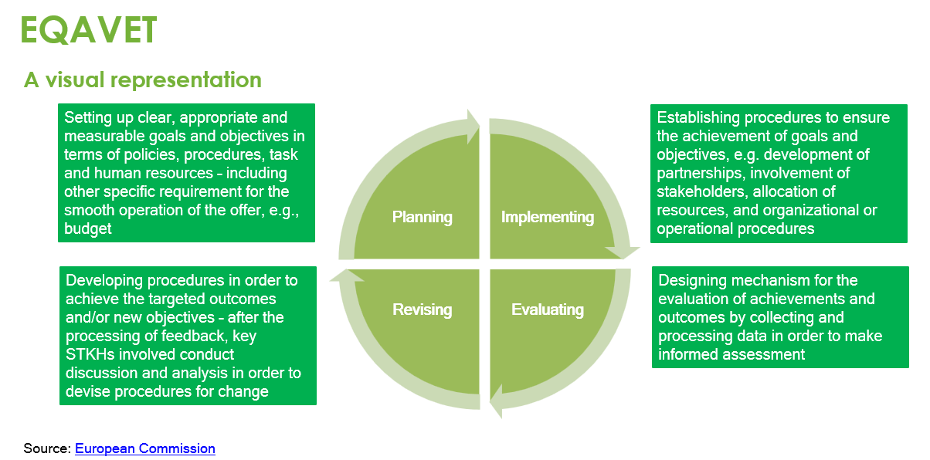  A two-folded application dimension  System level  The application at System level of the EQAVET framework helps member states and regional authorities in better understanding the effective quality and impact of their VET systems.  Specific indicators exist per each framework’s cycle to support the long-term improvement of the VET ecosystem as a whole.  Practice level  The application at Practice level of the EQUAVET framework helps education and training professionals in better adapting their offer to high-demand skills from the labour marker.  Specific indicators exist per each framework’s cycle to increase the flexibility and responsiveness of VET professionals  Unit 2: EQF  Section 2.1: The European Qualification Framework  The EQF is a transnational framework used to increase the comparability, transparency and international transferability of people’s qualifications at cross-national level. The EQF is currently adopted by all EU Member States and other 11 countries* and provides for a very comprehensive mapping of all possible ranks of qualifications.  Eight learning-outcomes based levels of qualifications are foreseen, with level 1 and level 8 as respectively the lowest and highest level of qualifications possible.  When designing and strategizing the content of training programmes, and learning outcomes desired, VET providers are recommended to look into the EQF and compare what is the positioning of their offer.  Leanirng outcomes are defined in terms of Knowedlge, Skills and Autonomy  Knowledge  In the context of EQF, knowledge is described as theoretical and/or factual.  Skills  In the context of EQF, skills are described as cognitive (involving the use of logical, intuitive and creative thinking) and practical (involving manual dexterity and the use of methods, materials, tools and instruments).  Responsibility  In the context of the EQF responsibility and autonomy is described as the ability of the learner to apply knowledge and skills autonomously and with responsibility  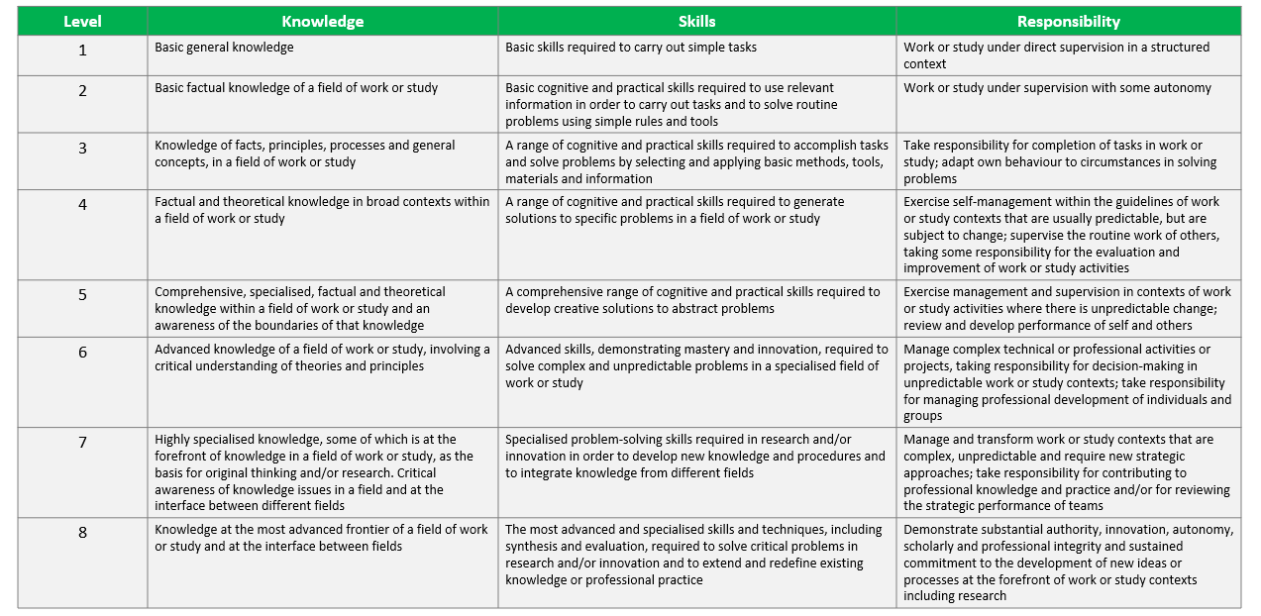  Unit 3: CEDEFOP – EU centre for the development of VET  Section 3.1: The go-to database for Vocational Education and Training  CEDEFOP is the EU agency for the development of education and training. The agency’s official website provides for several strategic resources for VET providers across Europe.  These kind of resources goes from publication and reports, to operative online tools available for the use of professionals from the most vary themes.  Most importantly, in cooperation with the European Commission, CEDEFOPS proactively operates to give concrete application to EU Parliament & Council’s 2009 ECVET recommendation – a common EU instrument to help individuals in transfer and accumulate their learning outcomes across EU.  Online tools  CEDEFOP European Database on apprenticeship schemes Financing Adult Learning Database National Qualification Frameworks online tools Skills-OVATE  European database on validation of non-formal and informal leaOnline tools rning Financing Apprenticeship Database Opinion Survey on VET Terminology of European education and training policy  European Skills and Job survey Key Indicators on VET Resource for guidance VET in Europe database  European Skills Index Matching Skills Skills forecast VET toolkit for empowering NEETs  European VET policy Dashboard Mobility Scoreboard Database Skills Intelligence VET toolkit for tackling early leaving  Source: CEDEFOP  Unit 4: EURES – The EU cooperation network for employment  Section 4.1: Facilitating the free movement of workers  EURES helps workers and job-seekers across Europe to find their ideal job, and employers to find their ideal candidates. VET providers can leverage on the EURES portal to ease the matching of demand and offer, and ease the transition into the job market of their students. More specifically, EURES’ services focus on the following:  - Matching of job vacancies and CVs on the EURES portal  - Information and guidance and other support services for workers and employers  - Access to information on living and working conditions in the EU member states, such as taxation, pensions, health insurance and social security  - Specific support services for frontier workers and employers in cross-border regions  - Support to specific groups in the context of the EURES Targeted Mobility Schemes  - Support to dynamic recruitment events through the European (Online) Job Days platform  - Information on and access to post-recruitment assistance, such as language training and support with integration in the destination country  Source: EURES  Unit 5: EURES – EUROPASS – learning and working in EU  Section 5.1: The EUROPASS’ use for VET providers  As we saw for EURES, EUROPASS is also another resource made available by the EU to ease the transition and movement of workers and job seekers in the labour market.  EUROPASS makes available a large cluster of services and resources that people can look into to prepare for their next big step in life.  Hence, VET providers themselves need to be very proficient and familiar with the kind of scale and scope of such resources to transfer their knowledge at best to their students.  Unit 6: EU Skills, Competences, Qualifications & Occupations  Section 6.1: The ESCO framework  ESCO is the official EU framework for the classification of Skills, Competences and Occupations. In practical terms, ESCO is used as the official glossary to describe in details all possible professionals occupations and the kind of skills and competences associated to them and that should be detained by workers.  The objectives of this standardization is to ease the mobility of workers and job seekers across the EU while supporting at the same time a much better and more integrated international labour market.  For VET providers, the use of ESCO is strategically relevant as it contributes to better frame the kind of learning outcomes that are needed by workers to access that job opportunity  Why is ESCO needed and what is its use  ESCO classifications can help people to understand precisely:  - …what knowledge and skills are usually required when working in a specific occupation;  - …what knowledge, skills and competences are obtained as a result of a specific qualification;  - …what qualifications are demanded or often requested by employers from those searching for work in a specific occupation.  ESCO contributes to generate several opportunities:  - …connects people and jobs, by providing for those key words that helps CVs in standing out  - …connects employment to education, by helping educators in gaining insights on the most in-demand skills and competences  - …connects the cross-national labour market & increases the mobility opportunities of job-seekers and workers  Source: ESCO  Unit 7: Micro-credentials  Section 7.1: The new “big thing” of the education and training ecosystem  Since the late beginning of the new decade, the EU has been particularly vocal of a renewed approach to education and training supported by the implementation and operationalisation of micro-credentials.  Unlike traditional training programmes (e.g., diplomas and degrees, etc) micro-credentials-based training and education initiatives works on a very specific filed of learning and the learning outcomes associated to it can be achieved over a sensibly shortened period of time.  Micro-credentials are becoming increasingly more popular in EU and at international level due to the higher degrees of flexibility they seem to guarantee and the befits of their practical use in very narrowed-focus education fields do not require extensive training programmes.  Still a new-born concept  The concept of micro-credential is still in a very early stage of development and no consensus on the very definition of micro-credential still exists.  The best reference available as of 2023 comes from UNESCO, as per which a micro-credential:  - Is a record of focused learning achievement verifying what the learner knows, understands or can do  - Includes assessment based on clearly defined standards and is awarded by a trusted provider  - Has standalone value and may also contribute to or complement other micro-credentials or macro-credentials, including through recognition of prior learning  - Meets the standards required by relevant quality assurance
Glossary | - A Micro-credential:  - Is a record of focused learning achievement verifying what the learner knows, understands or can do.  - Includes assessment based on clearly defined standards and is awarded by a trusted provider.  - Has standalone value and may also contribute to or complement other micro-credentials or macro-credentials, including through recognition of prior learning.  - Meets the standards required by relevant quality assurance.  Source: UNESCO https://unesdoc.unesco.org/in/documentViewer.xhtml?v=2.1.196&id=p::usmarcdef_0000381668&file=/in/rest/annotationSVC/DownloadWatermarkedAttachment/attach_import_2da68a70-ba6a-4af4-8381-bbef7425253c%3F_%3D381668eng.pdf&locale=en&multi=true&ark=/ark:/48223/pf0000381668/PDF/381668eng.pdf  - EQF: The EQF is an 8-level, learning outcomes-based framework for all types of qualifications that serves as a translation tool between different national qualifications frameworks. This framework helps improve transparency, comparability and portability of people’s qualifications and makes it possible to compare qualifications from different countries and institutions.  Source: Europass European Union  https://europa.eu/europass/en/europass-tools/european-qualifications-framework  EURES: The European employment services (EURES) is a European cooperation network between the European Commission, the European Labour Authority (ELA), the national public and other admitted employment services in all the EU countries, Iceland, Liechtenstein, Norway and Switzerland.  Source: ELA (European Labour Authority) https://www.ela.europa.eu/en/eures-network#:~:text=The%20European%20employment%20services%20(EURES,%2C%20Liechtenstein%2C%20Norway%20and%20Switzerland.  Europass: is a set of online tools and information that helps you manage every step of your learning and career. The tools and information support you in communicating your skills, qualifications and experiences clearly and consistently across Europe. The European Commission developed Europass..  Source: Europass European Union https://europa.eu/europass/en/what-europass-0  ESCO (European Skills, Competences, Qualifications and Occupations): is the European multilingual classification of Skills, Competences and Occupations.  ESCO works as a dictionary, describing, identifying and classifying professional occupations and skills relevant for the EU labour market and education and training.  Source: European Commission https://esco.ec.europa.eu/en/about-esco/what-esco#:~:text=ESCO%20(European%20Skills%2C%20Competences%2C,market%20and%20education%20and%20training.
Self-evaluation (multiple choice queries and answers) | 1. What is the DEMING cycle:  a) planning → implementation → checking → revising → planning → etc..  b) checking → implementation → planning → revising → planning → etc..  c) implementation → revision → checking → planning → etc..  2. What is the two-folded application of EQAVET?  a) System and Practice level  b) Basic and Advanced level  c) First and Second level  3. The EQF is:  a) All are correct  b) A transnational framewok  c) Currently adopted by all EU Member States and other 11 countries*  4. CEDEFOP is?  a) EU agency for the development of education and training  b) International agency for the development of education and training  c) EU agency for the job and training  5. Which of the following is correct?  a) EQAVET framework is inspired by the traditional DEMING cycle  b) EQAVET framework is inspired by the traditional EQAVET cycle  c) All are correct
Reference material
Resources (videos, reference link) | 20230610 - AMTECH - Training co-dev by IDP & IHF.pptx

